**How to Install OpenCV on Your PC**

ELEC 474 – Machine Vision

Fall 2019

**Introduction:**

This document describes step-by-step instructions to install OpenCV on a PC. The process described is derived from <https://www.deciphertechnic.com/install-opencv-with-visual-studio/>.

While there are many different versions of OpenCV that run on different operating systems and IDEs, we will focus here on OpenCV 4.1.1 running C++ on Windows10 using VisualStudio19. This is the version that will be used throughout the lab, and all software is available without cost. You are certainly free to use other operating systems or IDEs, but this configuration is the most commonly used. *TAs will exclusively provide support for the configuration described in this document. Note that versions of OpenCV prior to release 4.0.0 may have different compilation instructions, capabilities and syntax.*

**Prerequisites:**

The assumptions are that you are running Windows 10, and that you have suitable privileges on your PC to install software and change some environment variables.

**Step 1- Install Visual Studio:**

1. Download and install Visual Studio Community 2019 from:

<https://visualstudio.microsoft.com/vs/community/>

1. When prompted, add the “Desktop development with C++” Workload.
2. The complete installation will require ~7 GB of disk space. If you need to save space, you can uncheck all of the optional installation packages, and reduce the footprint to ~2 GB.
3. Reboot your computer when prompted.

**Step 2 - Install OpenCV:**

1. Download the Windows release of OpenCV 4.1.1 from: <https://opencv.org/releases/>
2. Save and run install file opencv-4.1.1-vc14_vc15
3. Select location to install (‘C:\’ is preferred)

***Do not install to paths with spaces!*** *Ex:* *C:\Program Files*

1. If prompted, select “yes to all”

**Step 3: Add OpenCV to system variables path**

* 1. From the start menu, search for ‘*Edit the system environment variables*’

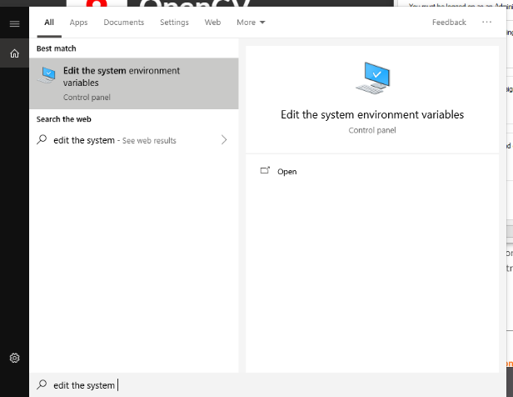

* 1. Under the ‘*Advanced*’ tab, select ‘*Environment Variables*’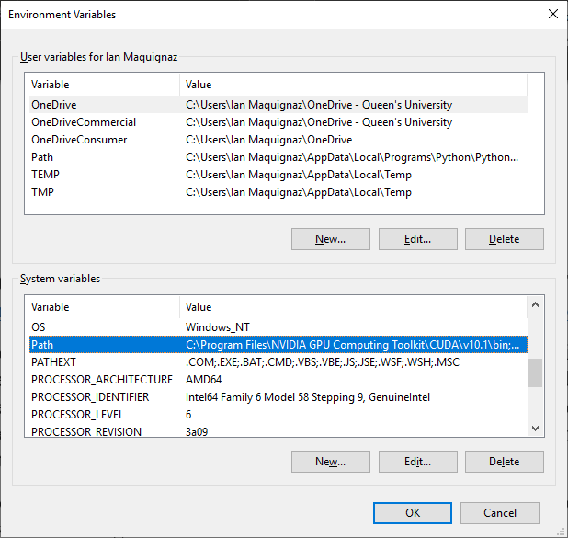
  2. Under ‘*System variables*’, double-click the ‘*Path*’ variable
  3. Click on ‘*New*’ to create a variable and insert the path of *bin*folder inside OpenCV package. The path should be similar to *C:\opencv\build\x64\vc15\bin.* ***Copy-paste the path to ensure it’s correct!***

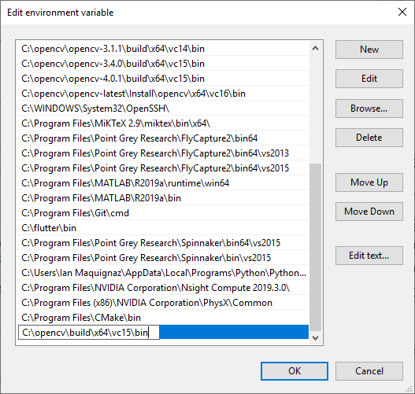

* 1. Press ‘*OK*’ and exit the environment variable dialog by clicking ‘*OK*’ again
  2. Restart your computer to let the updated Path variable take effect.

**Step 4: Create a new empty console application**

**[Optional]** Download the OpenCV-Visual Studios template project ‘ELEC-474 OpenCV Hello World_for_BAIN_ILC.zip’ from OnQ. It should work out of the box if you installed OpenCV to ‘C:\’. If it fails to build, debug by following the instructions below from step 7 onward. Note, there is a special zip folder for Bain and ILC computers called ‘ELEC-474 OpenCV Hello World_for_BAIN_ILC.zip’

1. Launch Visual Studio 2019.
   1. If you are prompted to login, use your Queen’s credentials.
2. Select ‘*Create a new project*’
   1. If prompted, under ‘*Development Settings:*’, choose ‘*Visual C++*’
      1. Select ‘*Start Visual Studio*’
3. Select ‘*Console App*’ and hit ‘*Next’*. **Make sure you select the project template for a *Windows* Console Application.** Linux ‘*Console App*’ may be an option on your system…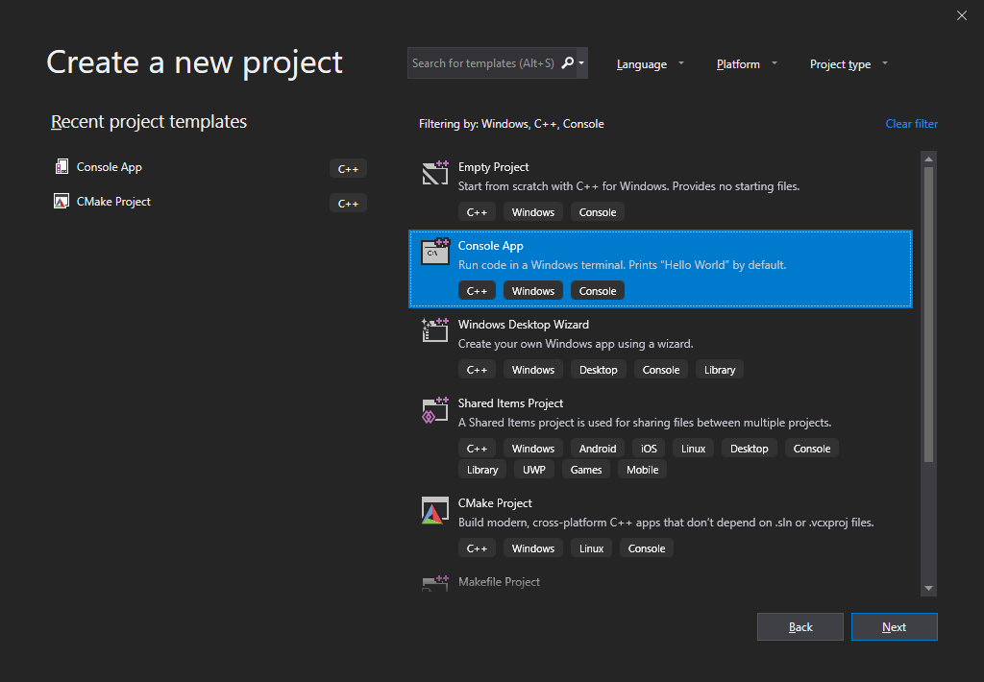
4. Give the project a name such as “OpenCV_HelloWorld” and select a location for it to be saved (the default is OK)

**Warning!**

**\*** It is not recommended to save projects to a path with spaces or special characters. It might work, but it also might not. Example*C:\Users\Bob the OpenCV-Builder*

**\* Note that Visual Studios has a ‘*feature*’ where files with a path longer than 260 characters cannot be compiled.**

**\*** For the reason above, **DO NOT save your project to the default OneDrive folder.**

1. Select ‘*Create*’ to populate your project
2. Replace the automatically generated “Hello World” code in ‘*main.*cpp’ with the following:

// Standard C++

#include <stdio.h>

#include <iostream>

using namespace std;

// OpenCV Imports

#include <opencv2/opencv.hpp>

#include <opencv2/core/core.hpp> // OpenCV Core Functionality

#include <opencv2/highgui/highgui.hpp> // High-Level Graphical User Interface

// [Optional] Use OpenCV namespace

// NOTE! If not included, all OpenCV functions will need to be prepended with "cv::"

// EX: "Mat image;" -> "cv:Mat image;"

using namespace cv;

int main(int argc, char** argv)

{

printf("hello world\n");

cout << "Hello World!" << "\t" << "HELLO WORLD!!" << endl;

// Create an image

cv::Mat image;

// Create 100x100 image of zeros

image = cv::Mat::zeros(100, 100, CV_16UC3);

// Import an image from a JPG

// Requires you to save an image named “image.jpg” inside your project.

//image = cv::imread("image.jpg", 0);

if (!image.data)

{

printf("No image data \n");

return -1;

}

std::cout << image.cols << "," << image.rows << endl;

// [Optional] Create a display window

cv::namedWindow("Display Window", cv::WINDOW_AUTOSIZE);

// Display the image

cv::imshow("Display Window", image);

// Wait for a keystroke in the window

// NOTE! If you don't add this the window will close immediately!

cv::waitKey();

// Terminate the program

return 0;

}

1. OpenCV 4.1.1 will only compile on x64 platforms.
   1. To remove other platforms auto-populated by visual studios, select the arrow to the right of ‘*x64*’ and select ‘*Configuration Manager*’ from the drop-down list.

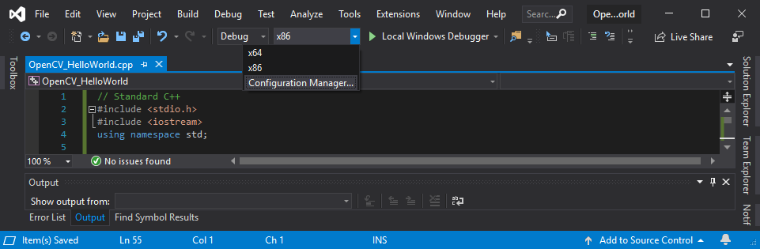

* 1. Select the dropdown below ‘*Active solution platform*’ and click ‘Edit’. Remove all Solution Platforms except for ‘x64’. Do the same for the dropdown below ‘*Configuration*’.

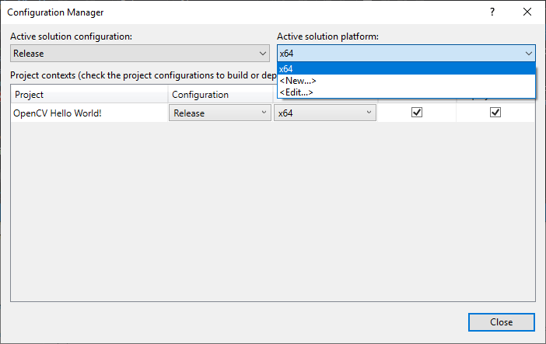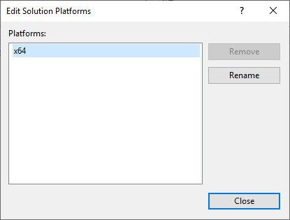

* 1. Select the dropdown below ‘*Active solution configuration*’ and click ‘Edit’. Remove all Solution Configurations except for ‘Debug’ and ‘Release’. Do the same for the dropdown below ‘*Platform’*

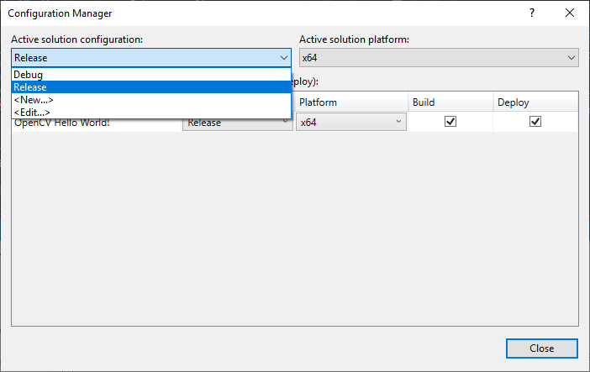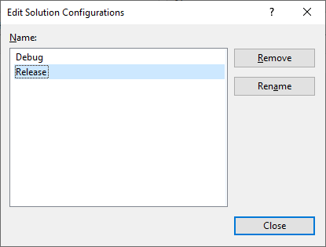

* 1. Close the ‘*Configuration Manager*’ dialogue box

1. Linking Project Configurations to OpenCV
   1. From the ‘*Solution Explorer*’, right-click the ‘*Solution*’ and select ‘*Properties*’ from the drop-down menu.

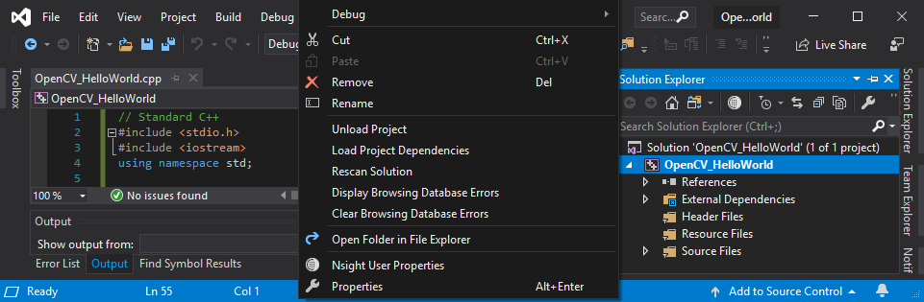

* 1. Select the drop-down list right of ‘*Configuration*’ and set the configuration to ‘*All Configurations*’

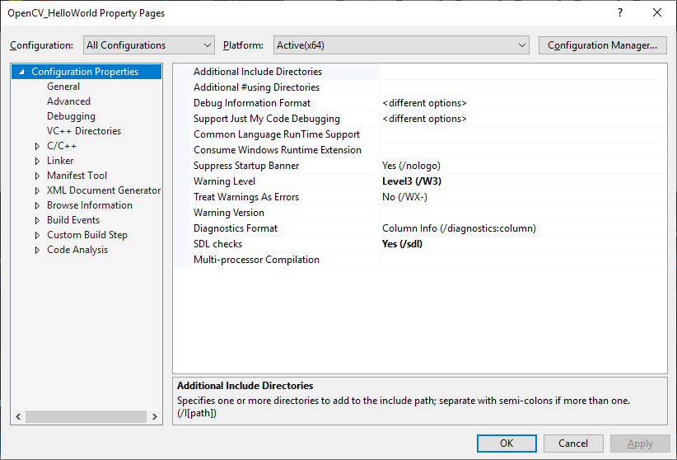

* 1. Go to *Configuration Properties 🡪 C/C++ 🡪 General*. Copy the path to the include folder of OpenCV and paste it inside ‘*Additional Include Directories*’. The path will look similar to *C:\opencv\build\include*. Then, click Apply.

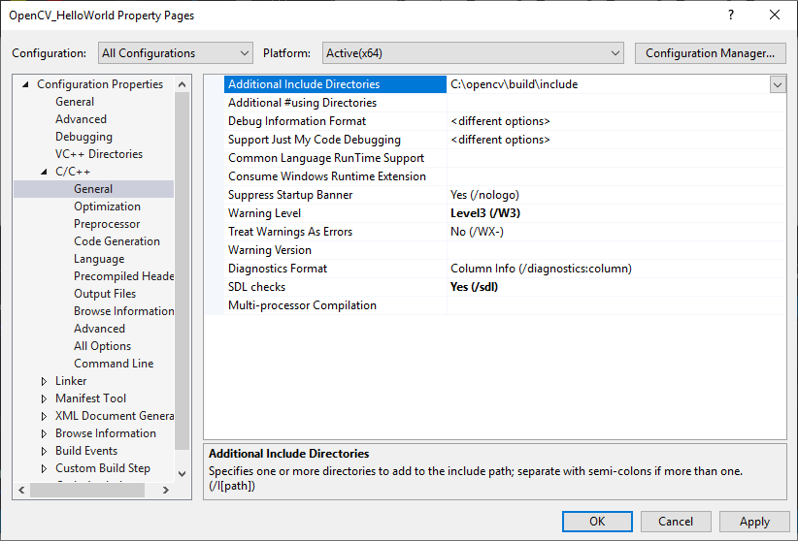

* 1. Go to *Configuration Properties🡪 Linker🡪 General*. Copy the path to the folder containing the OpenCV lib files and paste it inside ‘*Additional Library Directories*’. The path will look similar to *C:\opencv\build\x64\vc15\lib*. Then, click Apply.

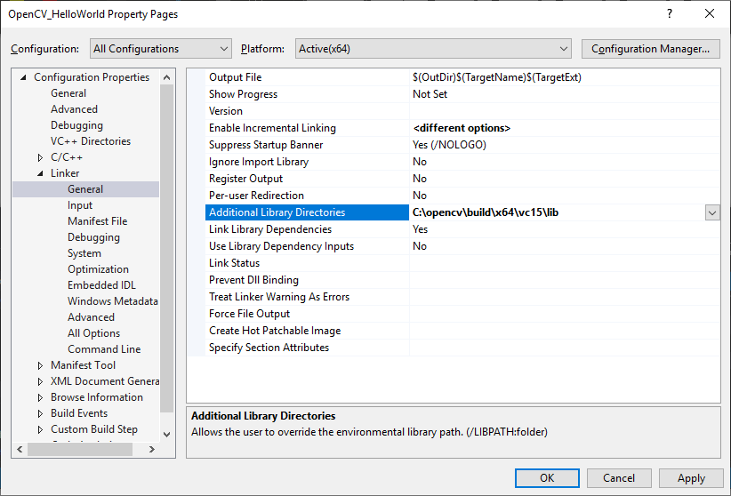

* 1. Go to *Configuration Properties🡪 Linker🡪 Input*. The settings on this page must be set independently for Debug and Release configurations:
     1. Set ‘Configuration’ to ‘***Debug***’.
        1. Edit ‘*Additional Dependencies*’ and paste the Debug OpenCV lib file name. For ‘Debug’ this lib should be ‘*opencv_world411d.lib*’
        2. Click ‘*Apply*’

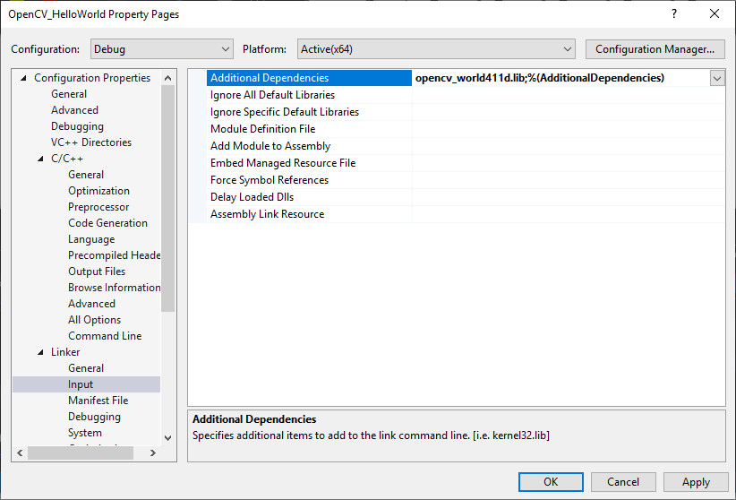

* + 1. Set ‘Configuration’ to ‘Release’
       1. Edit ‘Additional Dependencies’ and paste the Release OpenCV lib file name. For ‘Release’ this lib should be ‘opencv_world411.lib’
       2. Click ‘*Apply*’

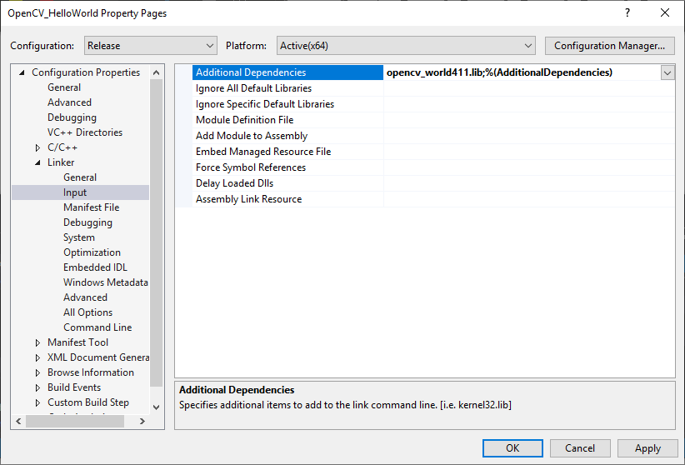

* + 1. Click ‘*Apply*’ and close the dialogue box.

***Note!***What’s the difference between ‘*Debug*’ and ‘*Release*’ configurations? ‘*Release*’ is a lot faster, but if you make a mistake, the error message (if any) will probably be useless. When using the ‘*Debug*’ configuration, error messages may have helpful information that will speed up solving the problem. Select between ‘Debug’ and ‘Release’ by using the drop-down menu shown in the image below.

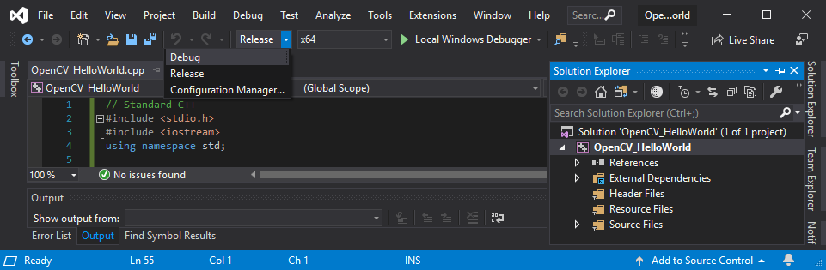

* 1. Exit the Properties by clicking ‘*OK*’.

1. Your installation should be complete! Click ‘*Local Windows Debugger*’ to run your program.

